zvelo Strengthens Support for Polish Language Websites
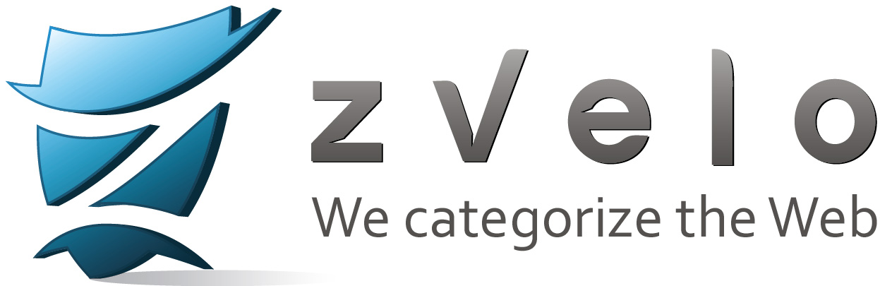

(1888PressRelease) zvelo responds to OEM Partner demand for URL categorization and coverage of Polish language websites
(1888pressrelease) Denver, CO - zvelo, a leading provider of website categorization and URL database solutions for OEMS, has announced full support for Polish language websites through its AutoCategorization (AutoCat) engine. AutoCat utilizes proprietary, artificial-intelligence technologies to categorize new URLs across dozens of languages and is backed by quality assurance from a team of over 125 multi-lingual Web Analysts.
"Polish language website query traffic to our zveloNET® systems have continued to increase," explains David Duncan, zvelo's Vice President of Engineering. "Releasing full language support for Polish websites strengthens the overall zveloDB® offering in the Eastern European block region."
The zveloDB URL Database can be integrated via an on-disk SDK or through the zveloNET cloud and can be evaluated for free by interested OEMs.
About zvelo, Inc.
zvelo is a leading provider of URL categorization technologies, URL database (zveloDB), malicious and compromised website detection and reputation blocklist solutions. zvelo licenses its zveloDB exclusively through technology partnerships with online advertising technology providers, service providers (ISP/MSSP, mobile, etc.), endpoint security and anti-virus vendors, UTM and gateway appliance vendors, content and URL filtering vendors, and other high growth market segments where accuracy, responsiveness, coverage, malicious website detection and fast URL query performance are required.
To learn more, visit https://zvelo.com.
Trackback Url :
http://www.1888pressrelease.com/zvelo-strengthens-support-for-polish-language-websites-pr-399982.html
###

